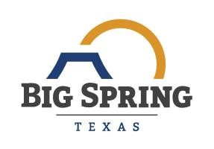
PUBLIC SERVICE ANNOUNCEMENT
Date: | February 20, 2024
To: | Media Outlets
From: | Shane Bowles, Public Works Director
Re: | Landfill and Golf Course Closed on Saturday

Due to the current rain and weather conditions, the Big Sandy Landfill and Comanche Trail Golf Course be closed on Saturday, April 20, 2024. If the weather improves, we will re-evaluate, but at this time, we anticipate the rain will continue all day. We apologize for any inconvenience. Questions should be directed to the office of Shane Bowles, Public Works Director, at 432-264-2501.

